Fourth code goes here

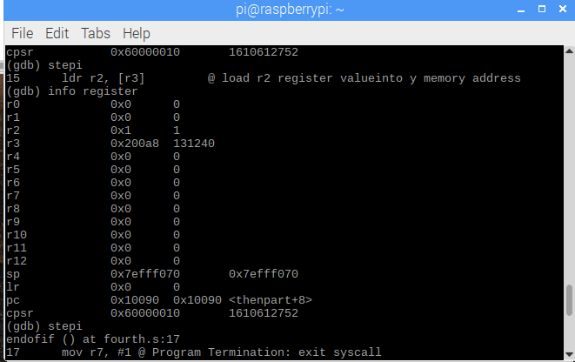

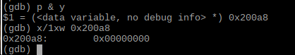

By examining the gdb, we can see that now y has value of one, because x=0 is a true statement, which cause y=1. In cpsr, we have zero flag on.

Fourth2 code goes here.

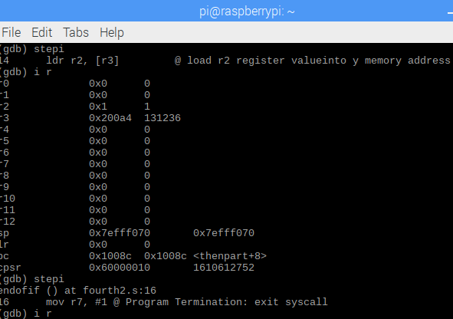

As we use the de morgan law and remove the b instruction, we still have the same result. However, this is much faster than before, because using b and beq back to back would cause a delay slot. Again, the zero flag is on.

ControlStructure1 code goes to here

For this code, we first load the value of x , which is 1 into r1, then i compared it with 3. If its greater than or equal to 3, we will go to the thenpart, where we subtract 2 from r2, else we subtract 1 from x. We implemented this by using de morgan law.

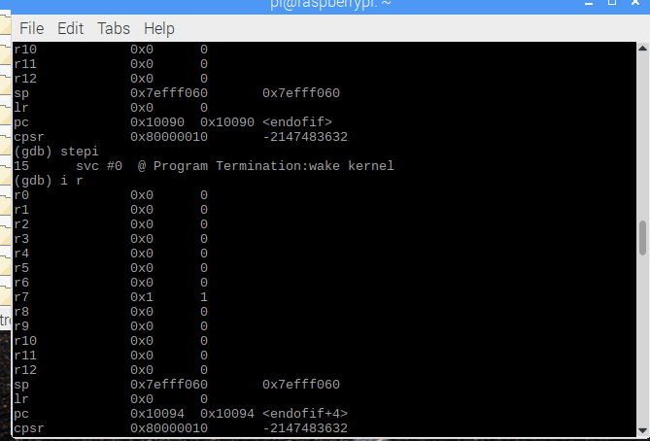

As we can see from the gdb, we now have r1, which is x=0 , because x=x-1=1-1=0. The zero flag is on.